NEW RULES TO KEEP EVERYONE SAFE
PLEASE ARRIVE NO MORE THAN 5 MINUTES BEFORE YOUR APPOINTMENT
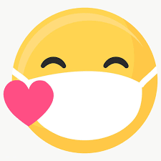PLEASE WEAR A MASK All stylists and guests are required to wear a face covering in the salon and should be worn throughout the entire appointment. (Available at a small cost from reception if you do not have one)
SAFETY CHECK-IN We will take your temperature when you arrive. (Please do not come in if you feel unwell or have been caring for someone sick in the past 14 days)
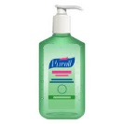SANITISE TOGETHER We will provide hand sanitiser at every station and ask that you sanitise your hands before every appointment. Staff will be washing their hands and sanitising regularly.
GUESTS ONLY Please come alone to your appointment, no waiting please. Children can be accompanied by one adult.
ONLY BRING THE MINIMUM YOU REQUIRE TO YOUR APPOINTMENT No shopping bags or excess clothing if possible
COMPLIMENTARY DRINKS AND MAGAZINES On pause for now Feel free to bring your own.
KEEPING A SAFE DISTANCE Social Distancing will be practiced throughout the salon.
CLEANING AND SANITISATION STANDARDS All stations, tools and products are being thoroughly cleaned and sanitised between every service.
CASHLESS PAYMENTS 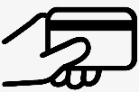 Please remember to bring your card! We will not be accepting cash payments at this time.
RETAIL SALES
Please do not handle retail products ask the stylist if you would like to buy any of our products.
NO DRY CUTS
DON’T WORRY IT MIGHT BE DIFFERENT BUT ITS STILL US

